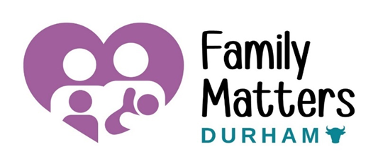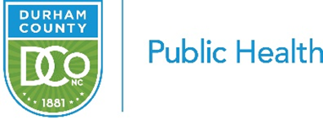

Family Matters Durham: Welcome to Our Spring Edition!

Dear Community,
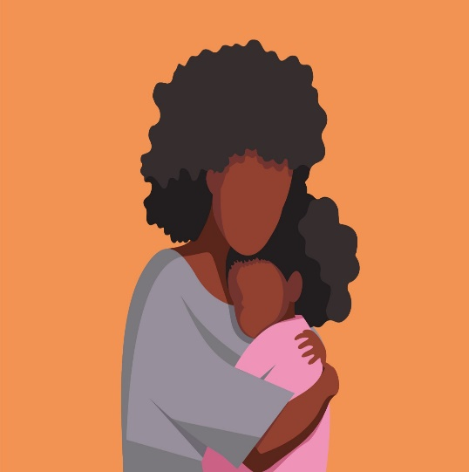
As the vibrant colors of spring begin to bloom and the days grow longer, we're reminded of the season of renewal, growth, and the beauty of life’s transitions. This time of year, is the perfect time to reflect on the importance of care, support, and community—especially as we recognize Black Maternal Health Week, taking place from April 11 to April 17. This week is dedicated to raising awareness about the disparities in maternal health outcomes that affect Black women and highlighting efforts to improve care, support, and advocacy for Black mothers.
Let us reflect on the incredible journeys of families, acknowledge the challenges, and shine a light on the efforts that continue to improve the health and well-being of mothers and children everywhere. We encourage you to seek opportunities that increase the critical need for improved maternal health care and outcomes for Black women, and to celebrate the resilience, strength, and empowerment of Black mothers.=
In this edition, we’ll explore ways to support Black women, share resources for expectant families, and highlight efforts being made in maternal and child health. We hope this season of growth inspires you as much as it inspires us, and that together, we continue working toward a healthier and more equitable future for all mothers and families.
Join Our Community Action Team Meeting!
Helping Improve Maternal and Child Health in Durham County

We invite everyone who is passionate about improving maternal and child health to join us in making a positive impact! Our Community Action Team (CAT) includes family leaders, community members, local organizations, and partners, all working together to improve the health and well-being of Durham County.
Come be a part of the change!
We meet every other month, on the 2nd Wednesday. Our next meeting will be on April 9th—details are below. We’d love to see you there!

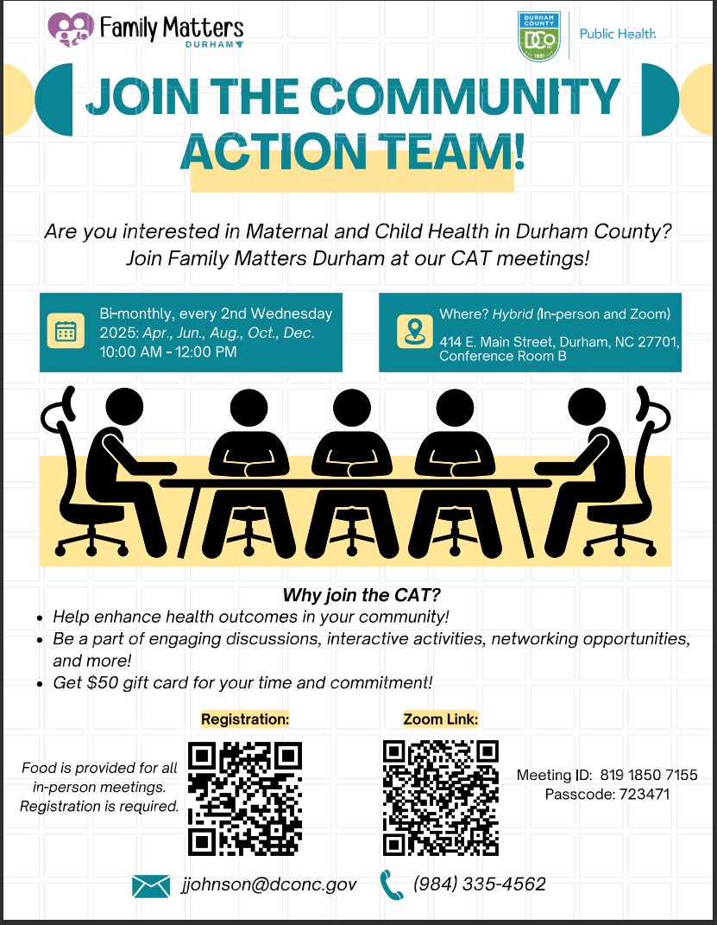

Ready, Set, Baby!
Family Matters Durham offers FREE prenatal breastfeeding classes – Ready, Set, Baby! This class offers education for pregnancy, birth, and postpartum care to support new parents getting ready for their baby, whether they are adding to their family or first-time parents. There is also a FREE raffle prize at the end of each class for parents and/or baby.
Remaining Dates: April 3rd, April 17th, May 1st, May 15th, May 29th
Morning Class: 10 AM – 12 PM
Afternoon Class: 1 PM – 3 PM
Zoom – Meeting ID: 894 9887 2147, Passcode: 535450
https://us02web.zoom.us/j/89498872147?pwd=QGXyR9PzkeqCaeAyjWZailEeLLXWrU.1
Spanish classes coming soon!

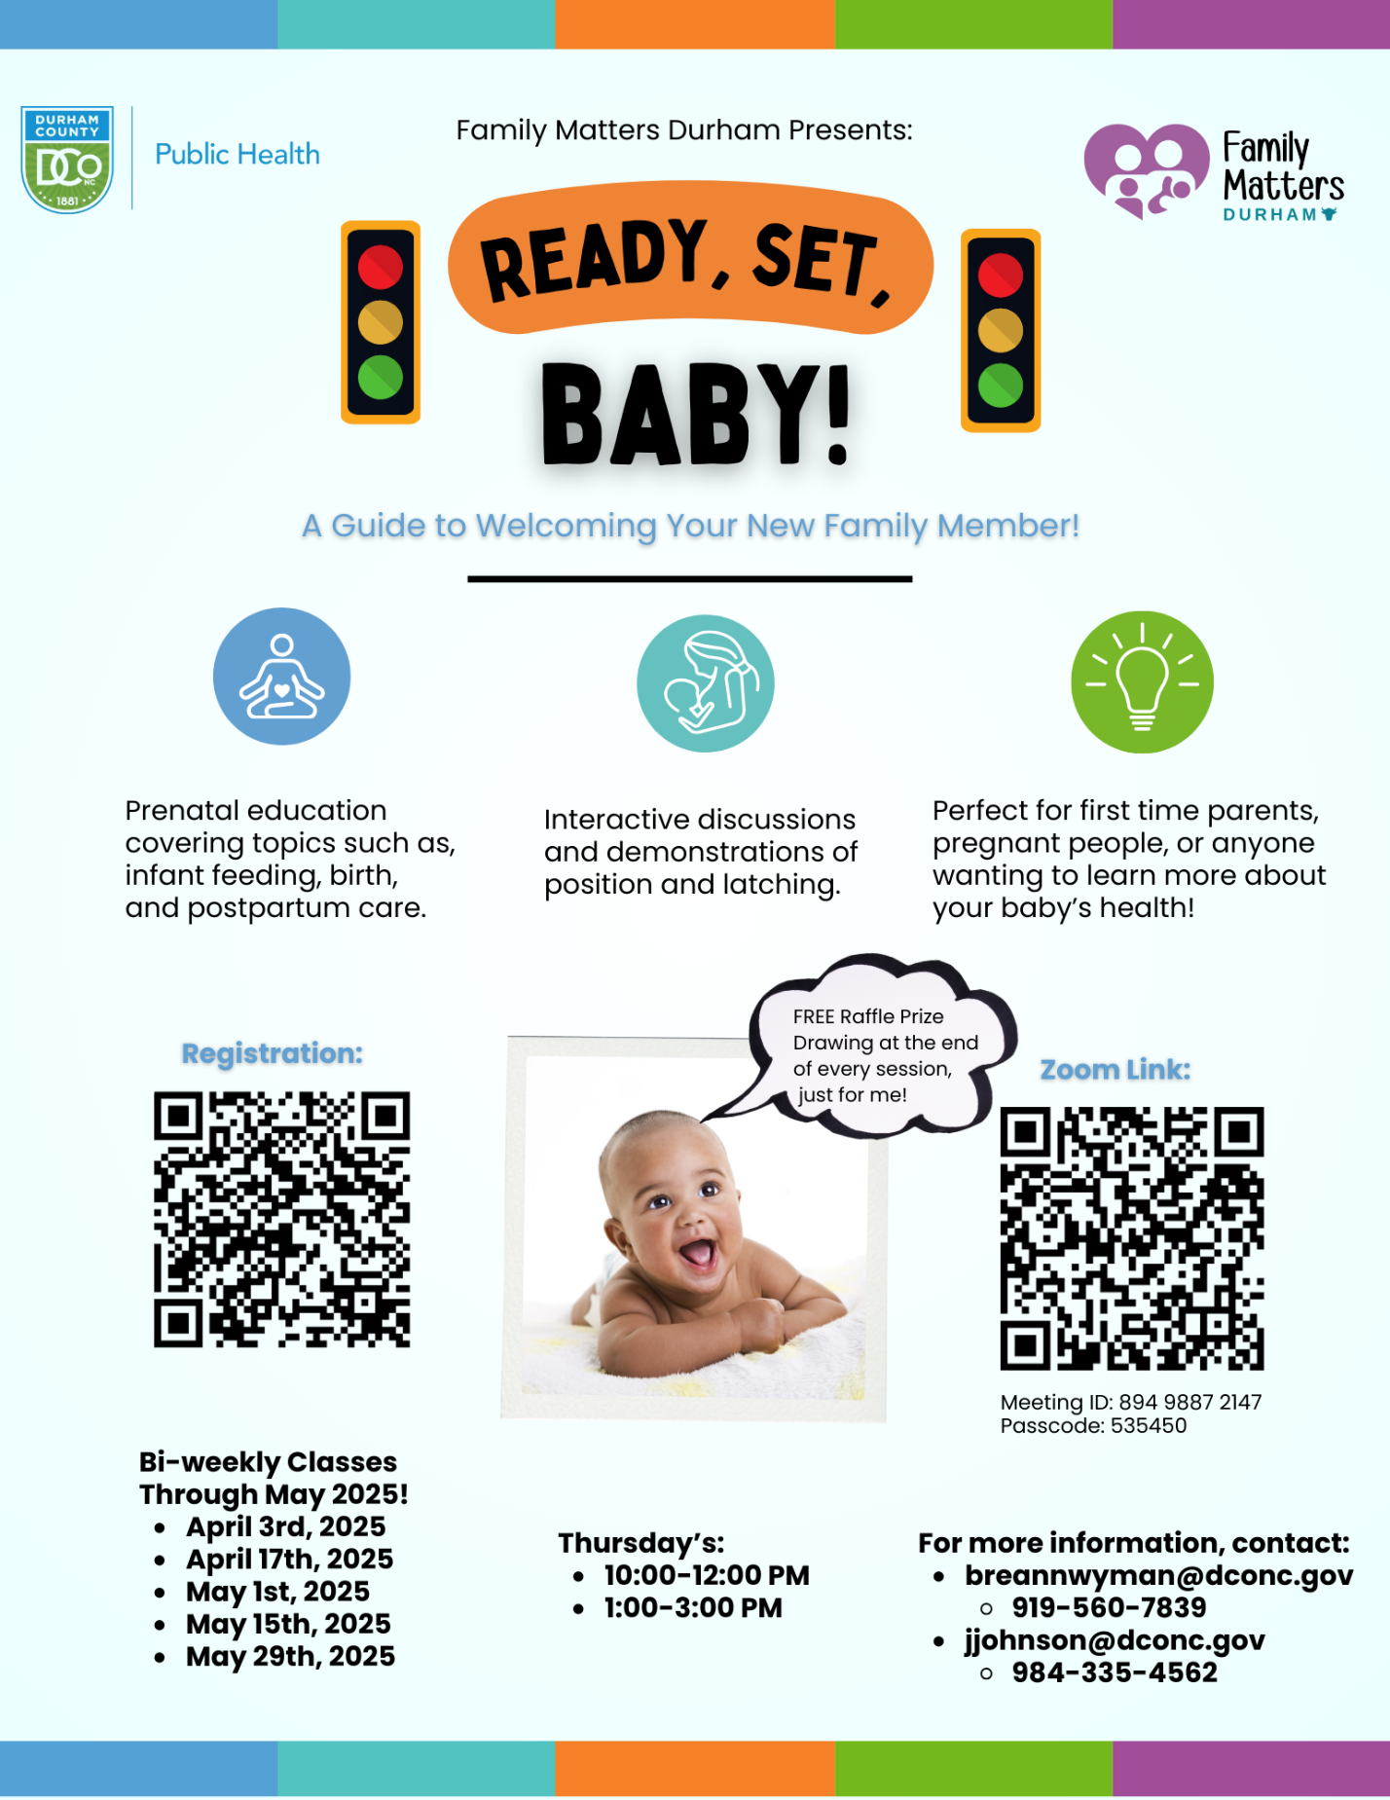

Mothers and Babies!
Family Matters Durham is offering a FREE, in-person program called Mothers and Babies for pregnant women, new moms, and families. This program offers skills on how to manage stress and reduce symptoms of postpartum depression. Over 6-9 weeks, classes help parents focus on building healthy habits, positive thinking, and social support. Classes are offered 1-on-1 or in a group. 1-on-1 sessions are available now! Next group begins week of April 20th!
Registration: Family Matters Durham Mothers and Babies Registration

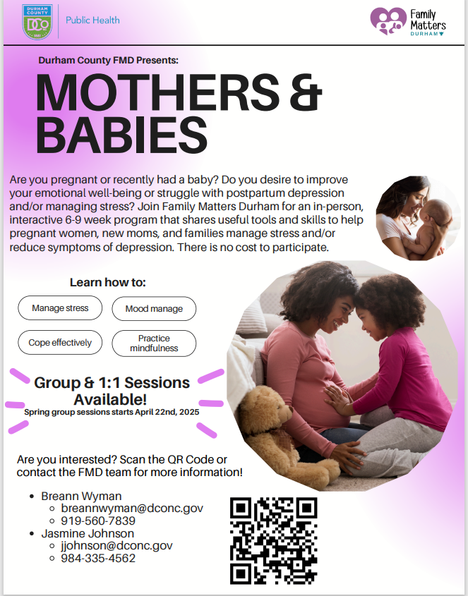

Tips for Engagement

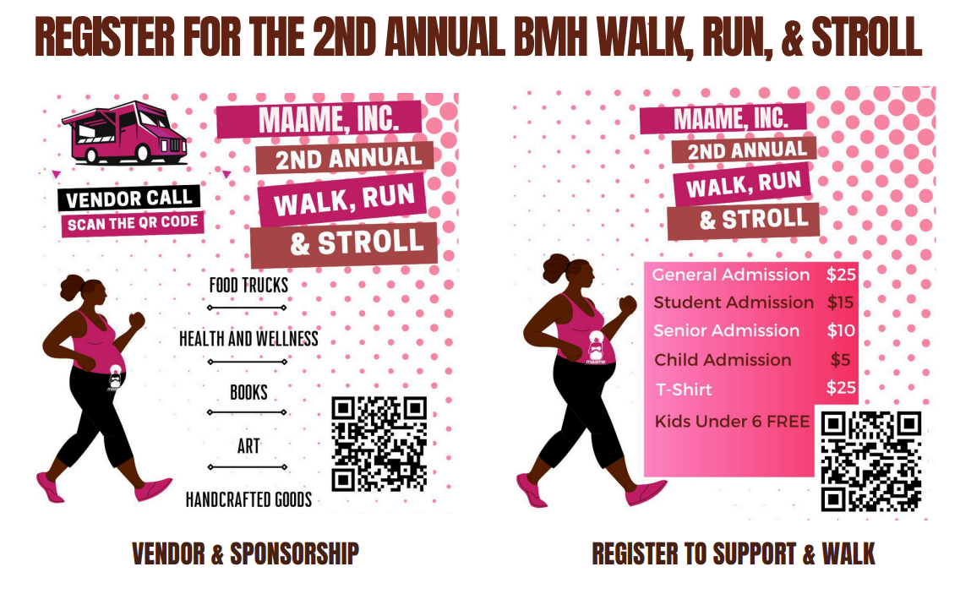

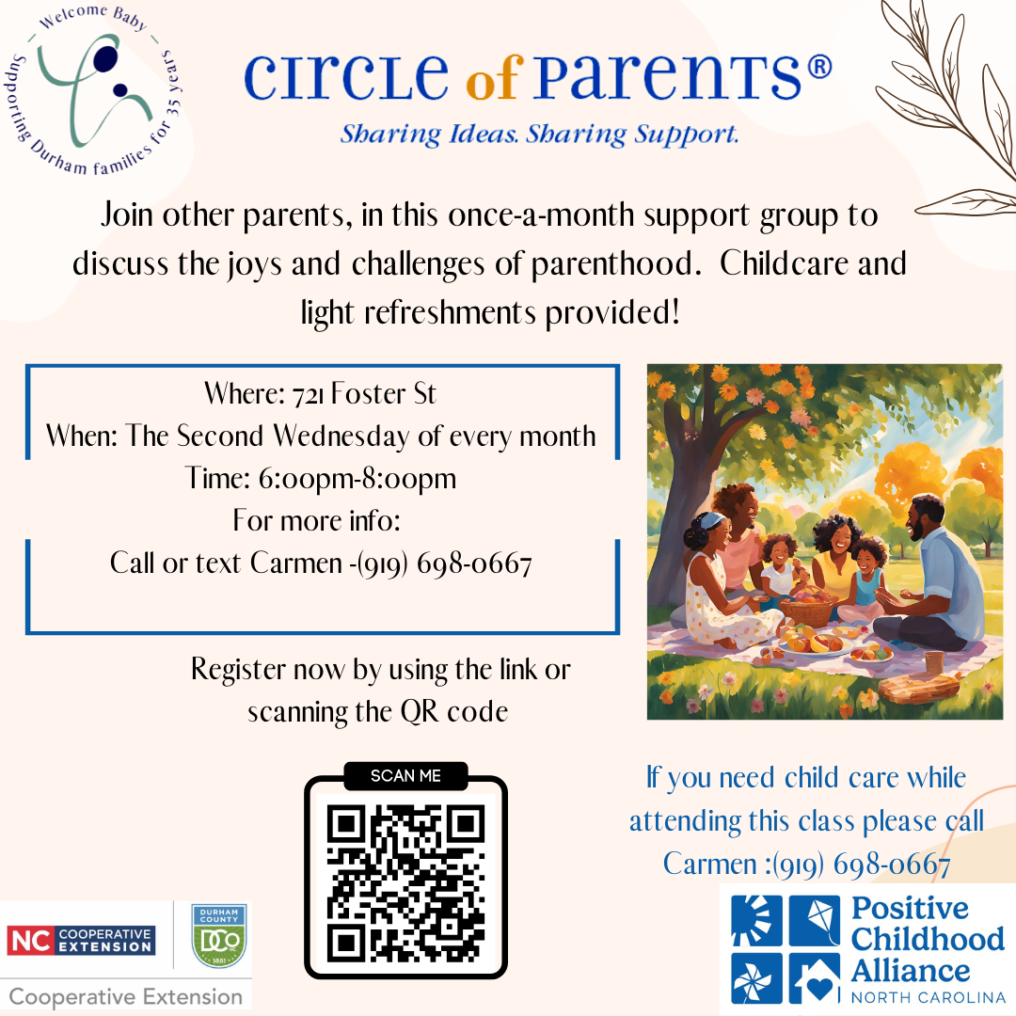

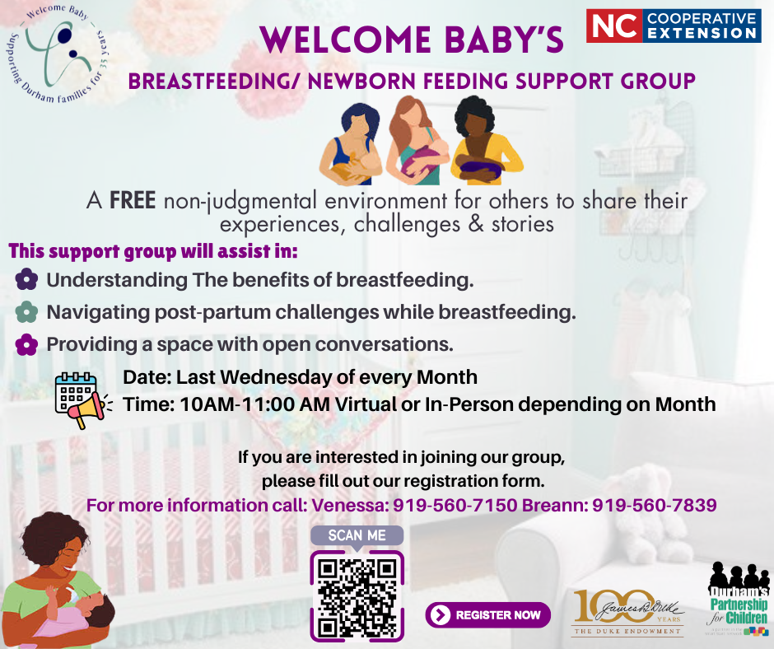

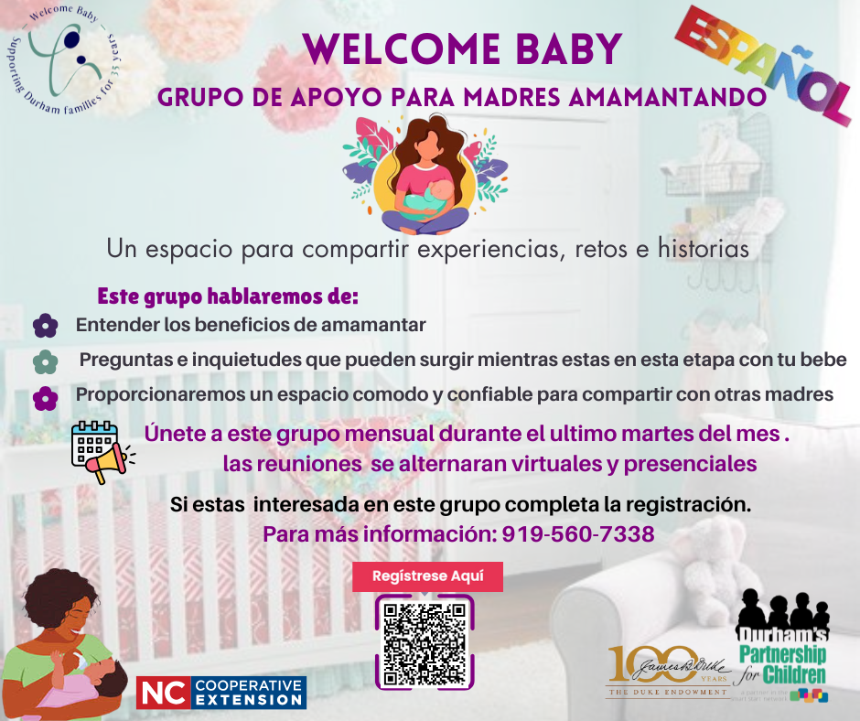

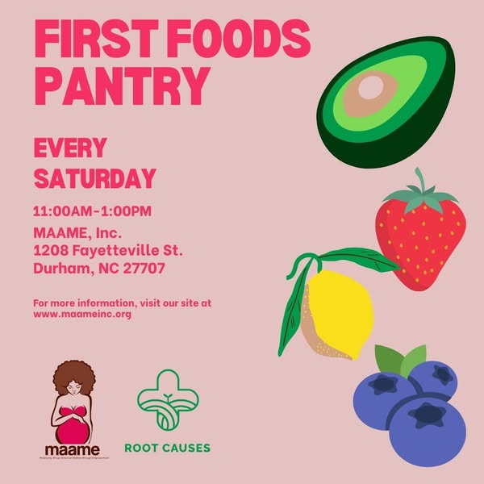
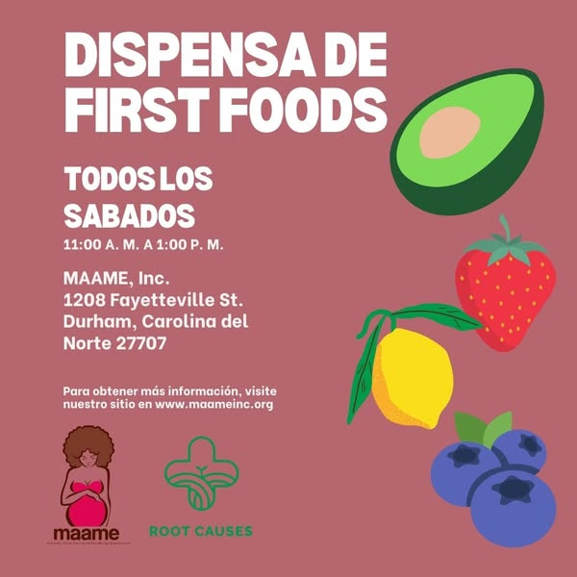

Additional Opportunities
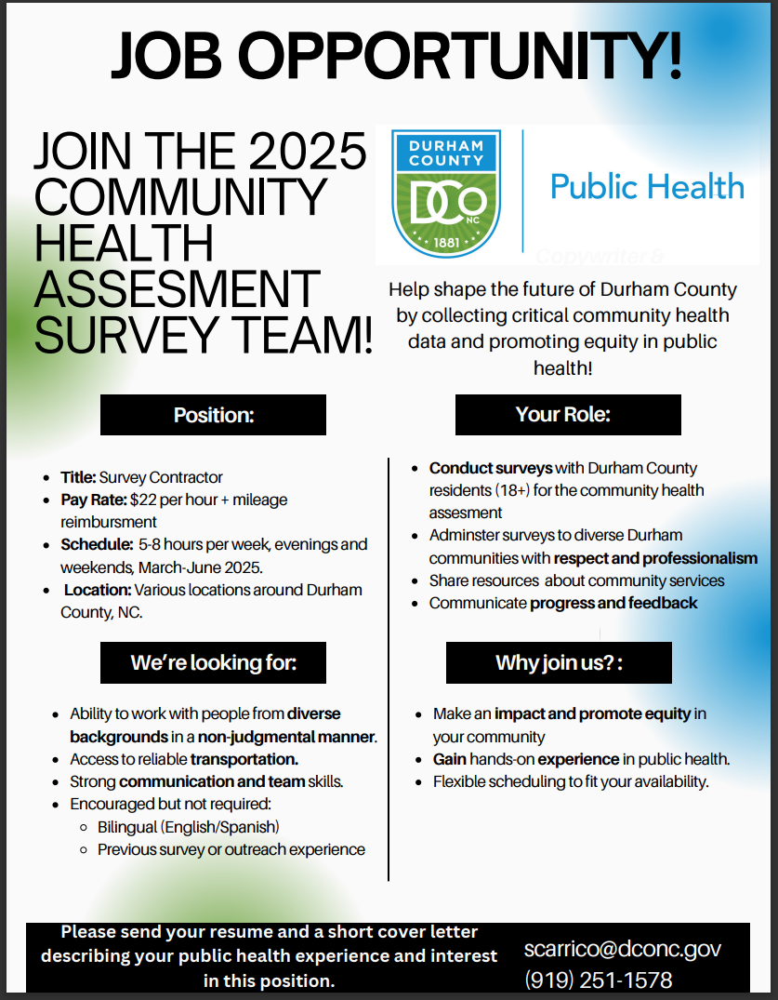

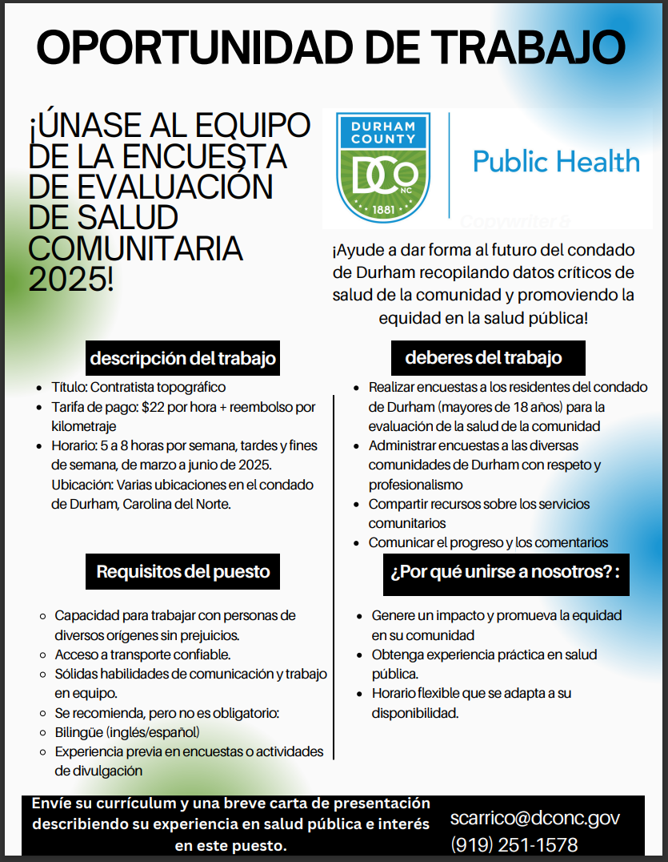

Community Spotlights

Meet our new Community Health Worker – Gracie Rico Mendoza!
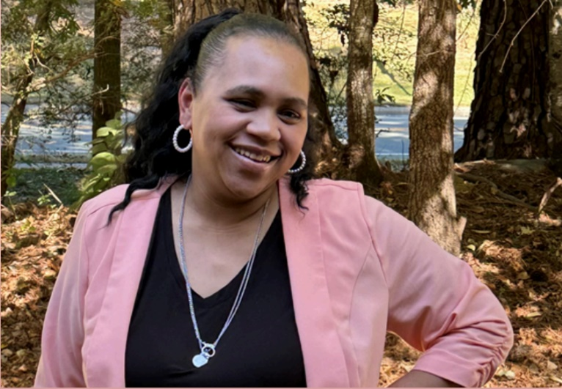
Gracie, from Carrboro, NC, is a community health worker excited to provide education to Spanish speaking families. Gracie is originally from Carrboro, NC. She loves reading and enjoys teaching her kids new things while learning from them too. Gracie is dedicated to supporting new moms, especially those struggling with breastfeeding. Having faced her own challenges while nursing her son, Gracie is eager to offer the guidance and encouragement she wishes she had received. Her mission is to help moms feel empowered and remind them they’re not alone in their breastfeeding journey. Gracie will be working with our Spanish-speaking families and teaching our educational classes – Mothers and Babies & Ready, Set, Baby.



Well, that’s all for now. Thank you to our community for your support! We encourage you to stay tune for more upcoming events and get involved with our initiative. For more information, please contact the Local Program Manager, Jasmine Johnson at jjohnson@dconc.gov.

Until next time,

Family Matters Durham

Family Matters Durham core community partners are:
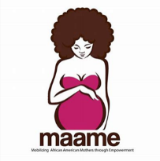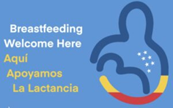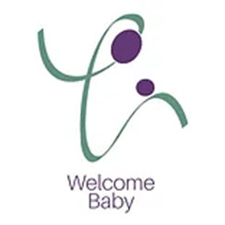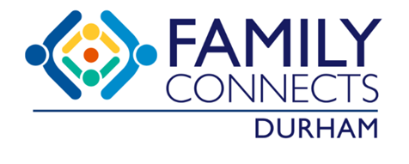

Family Matters Durham is funded under the Improving Community Outcomes for Maternal and Child Health (ICO4MCH) initiative by the North Carolina Division of Public Health.

